Enel and ESA launch new Snow Water Equivalent feasibility study in Italy with Wegaw’s satellite based snow monitoring solution

Alpine region of South Tyrol in Italy taken by Markus Spiske (Source: Unsplash)

The Swiss/Spanish pioneering climate tech start-up - Wegaw - has won the opportunity to deliver a technical feasibility study of snow water equivalent values that would support a scalable nowcasting and forecasting energy generation solution for a cluster of hydropower plants across northern Italy.

Through Wegaw’s deep learning geospatial tech platform and expertise in snowpack dynamics, as well as continuously available data from satellites managed by the European Union Agency for the Space Programme (EUSPA) in partnership with the European Space Agency (ESA) and the National Aeronautics and Space Administration (NASA), the results of this new feasibility study “Space for Hydro Energy” will feature seasonal best practice and assessment methodology to enable a more accurate prediction of complex snow water equivalent (SWE) variables.

Whilst people have been reading the night skies, creating maps, and using water as a source for energy for thousands of years, the use of commercial satellite data to create geographic information systems (GIS) is relatively new. However, since early concepts of quantitative and computational geography emerged in the 1960’s, the development and innovation timeline of GIS has increased exponentially.

“We have been working with representatives of the Earth Observation (EO) service industry as well as energy companies and utilities to explore how satellite data can be exploited for the greater good for more than 20 years now.  Our groundbreaking international projects and satellite missions foster progressive development in the pollution-free hydro power industry and we are very pleased to collaborate with Wegaw again to discover further enhancement opportunities that would benefit energy needs whilst closing the gap on fossil fuel dependencies.” | Davide Coppola  Head of Space Applications Initiatives

Due in part to ongoing sustainability innovation, and the tireless dedication by energy companies and stakeholders to optimize renewable power operations, today almost 60% of the entire world’s green energy is generated by hydropower plants. However, in order to effectively manage hydroelectric plants and plan the production or storage of water, it is necessary to understand numerous physical parameters, such as rain and snow precipitation, seasonal snowpack compression and melting, and local geomorphology.

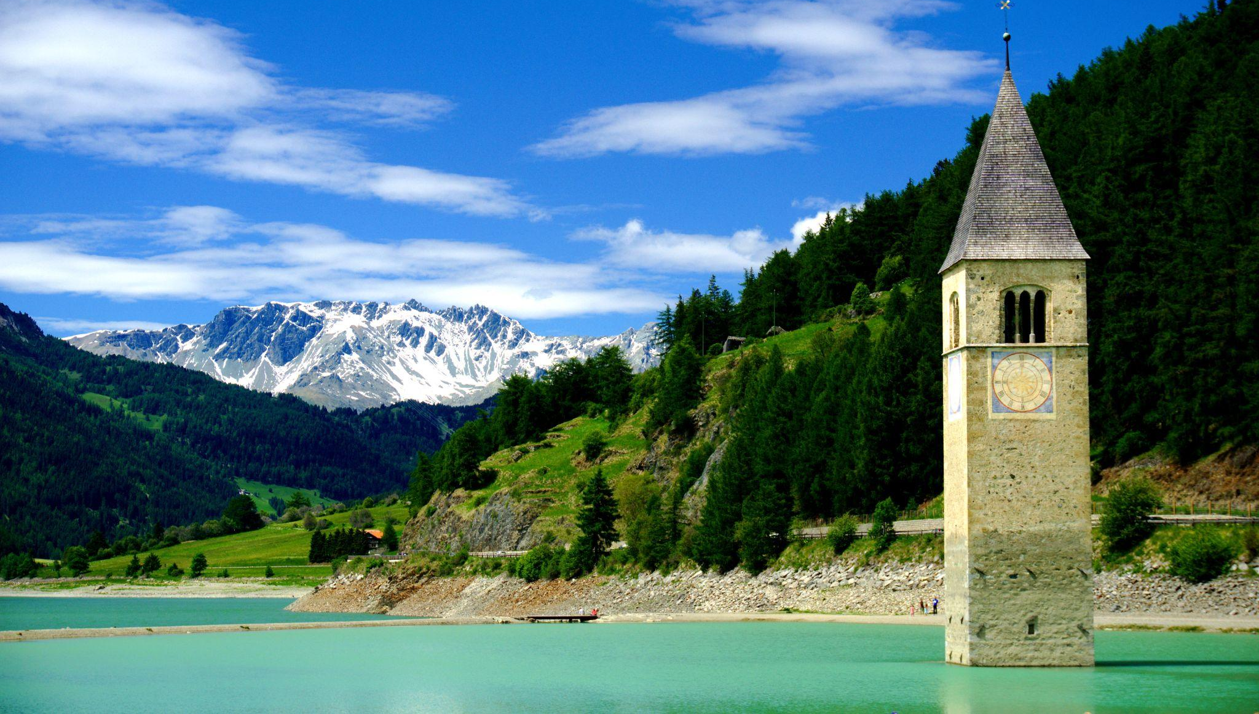
Abandoned bell tower (Kirchturm) at the old town of Altgraun in Curon Venosta, Italy. A beautiful landmark
under monument protection which is situated near a hydro plant. Photo taken by Felix (Source: Unsplash)
“Our team is very proud to work with Wegaw and ESA on hydro energy transition optimization and we are looking forward to seeing the results of our collaboration very soon.” | Marco Favarato  Head of Enel Innovability® Global Energy and Commodity management
The primary aim of this work is to support Enel in further improving its understanding of snow dynamics to maximize the optimization of the hydropower system in the north of Italy.
Furthermore, this opportunity will enable Wegaw to boost its already highly accurate and reliably tested data modelling capabilities through the incorporation of a broader range of physical characteristics that would cover a variety of different snow types and complex dynamics.
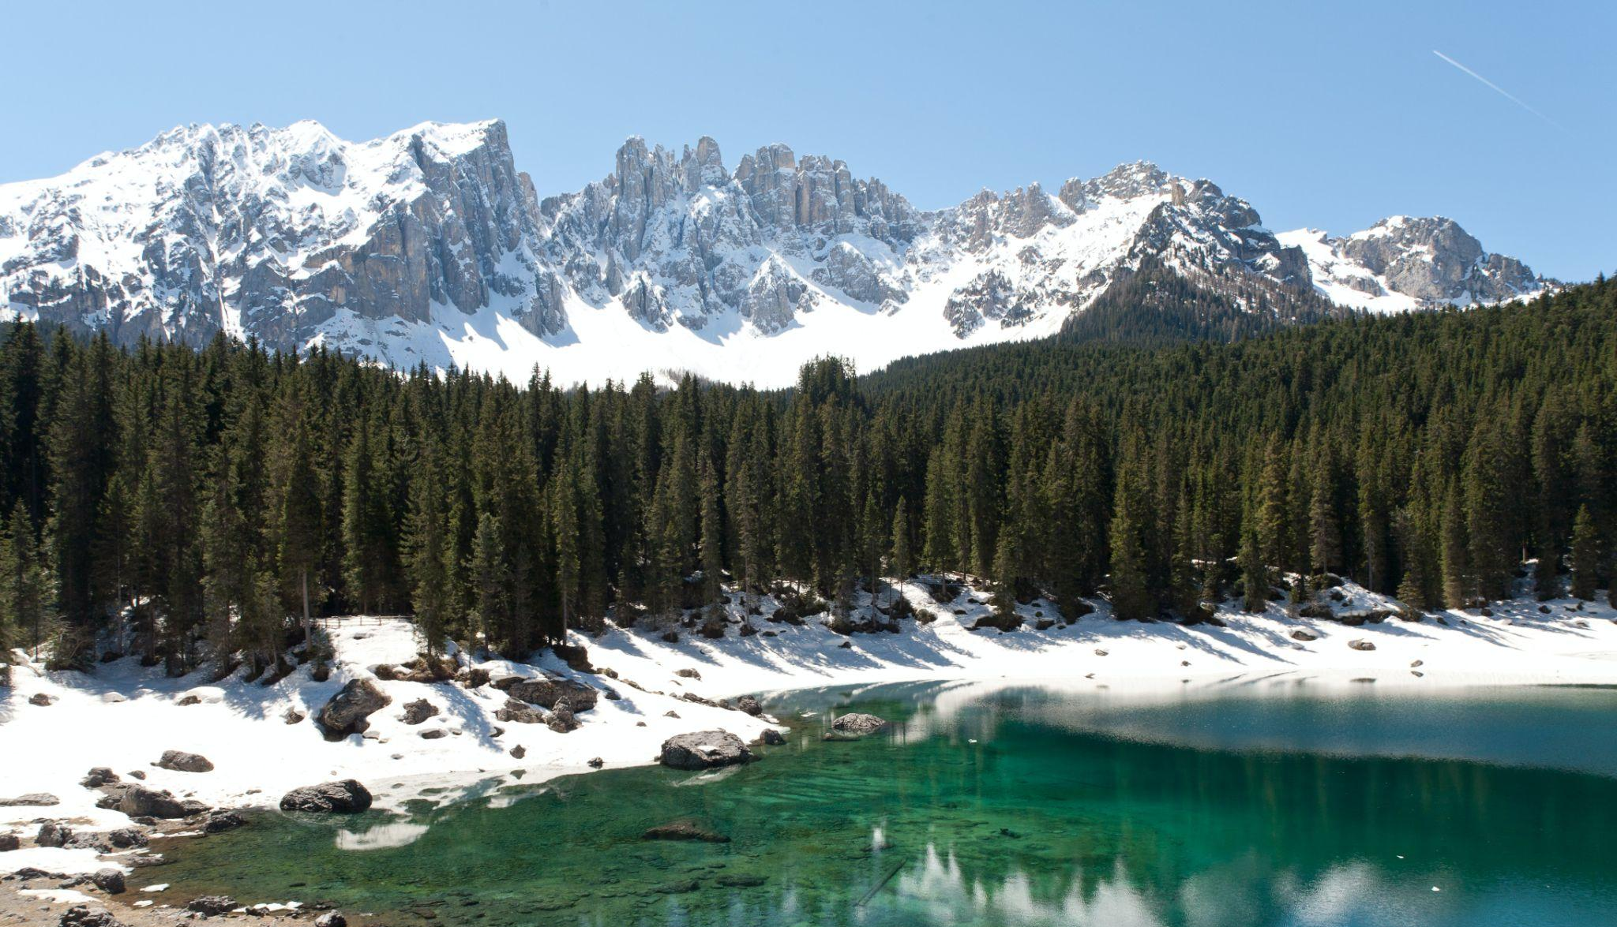
Karersee, South Tyrol, Italy taken by David O. Andersen (Source: Unsplash)

After 3 years in the lab working with the most knowledgeable organizations in the world, both in Geospatial technology (European Space Agency) and snow dynamics (The WSL Institute for Snow and Avalanche Research SLF), in 2020 Wegaw launched the first snow monitoring SaaS based on satellite data. Since then, the startup has successfully delivered actionable datasets that are created from satellite data and a unique combination of machine learning algorithms. For instance, the below low resolution map of SWE data, demonstrates this Wegaw's results from a group of hydrological basins in Valais, Switzerland:
The resolution of this map is 100m. Wegaw usually provides much more detailed data analysis and can do so for any regional scale without the need for LiDAR drones, meteorological data, snow pillow sensors or field measurements.
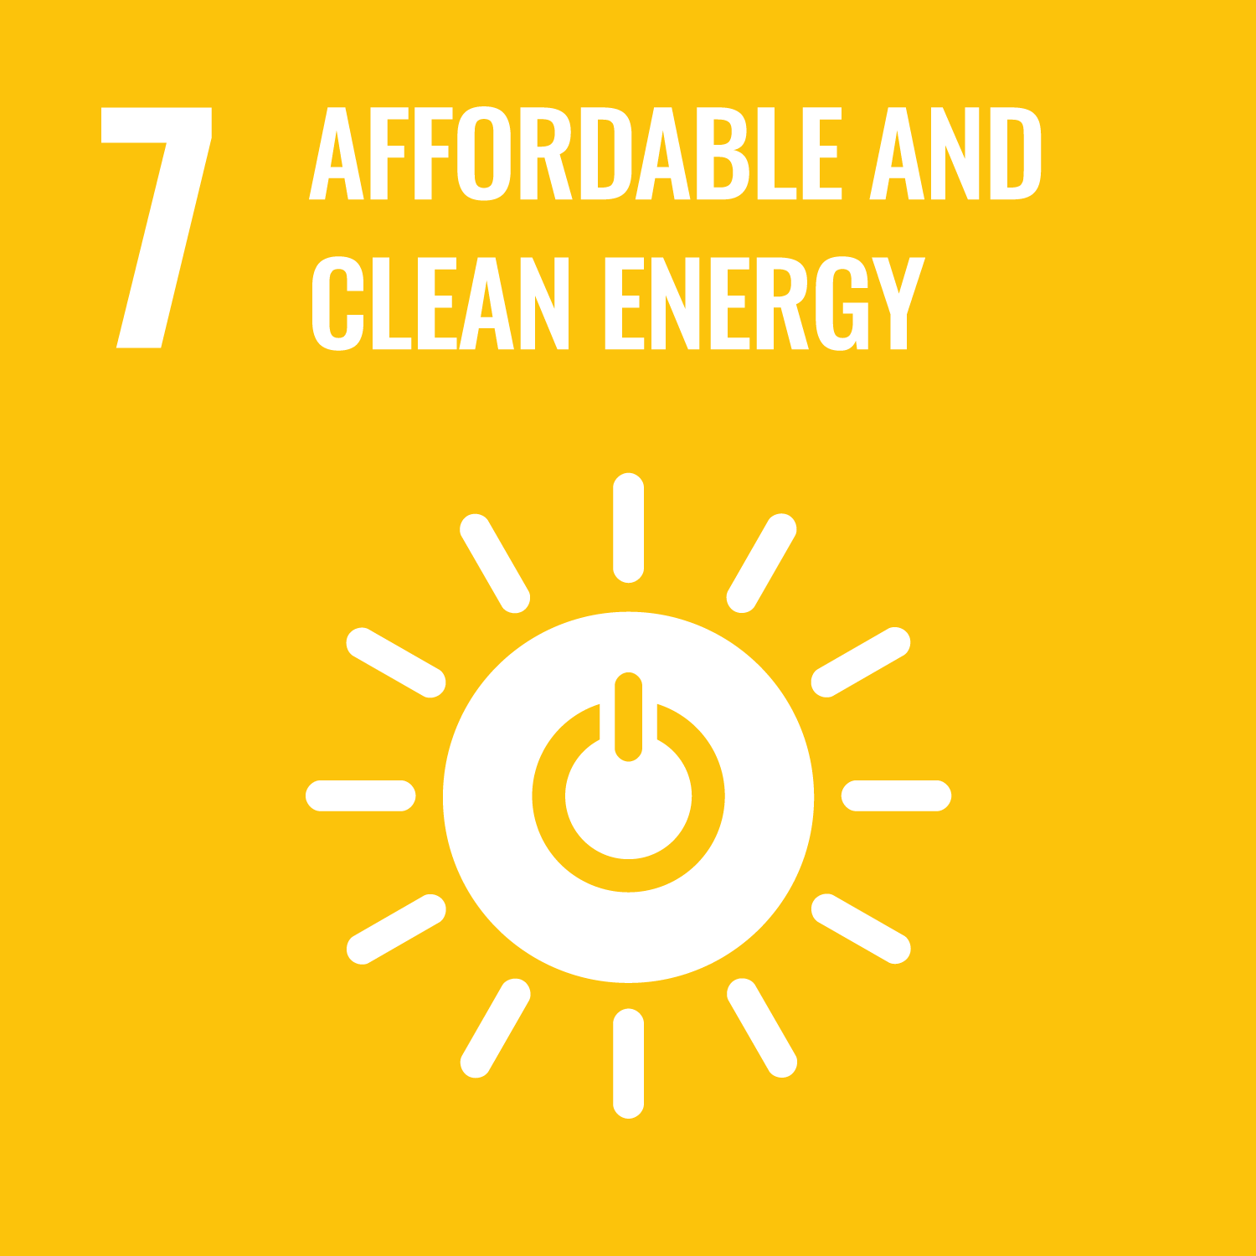  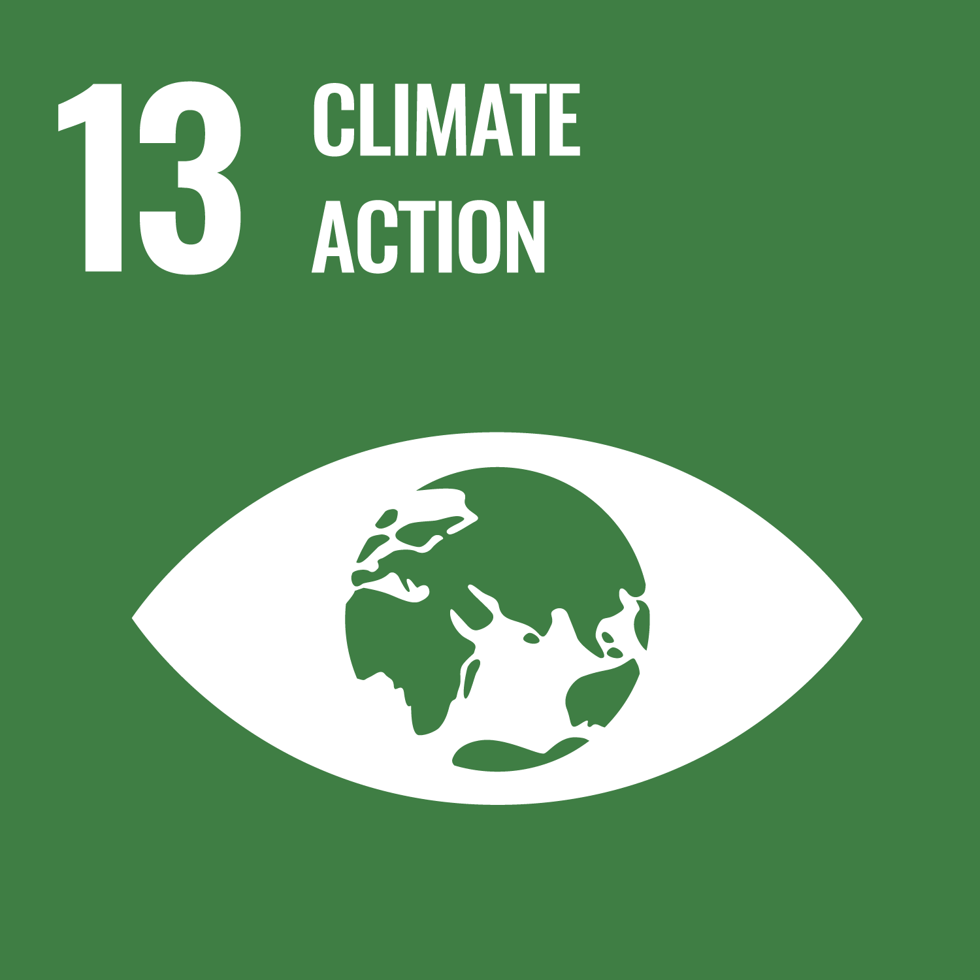  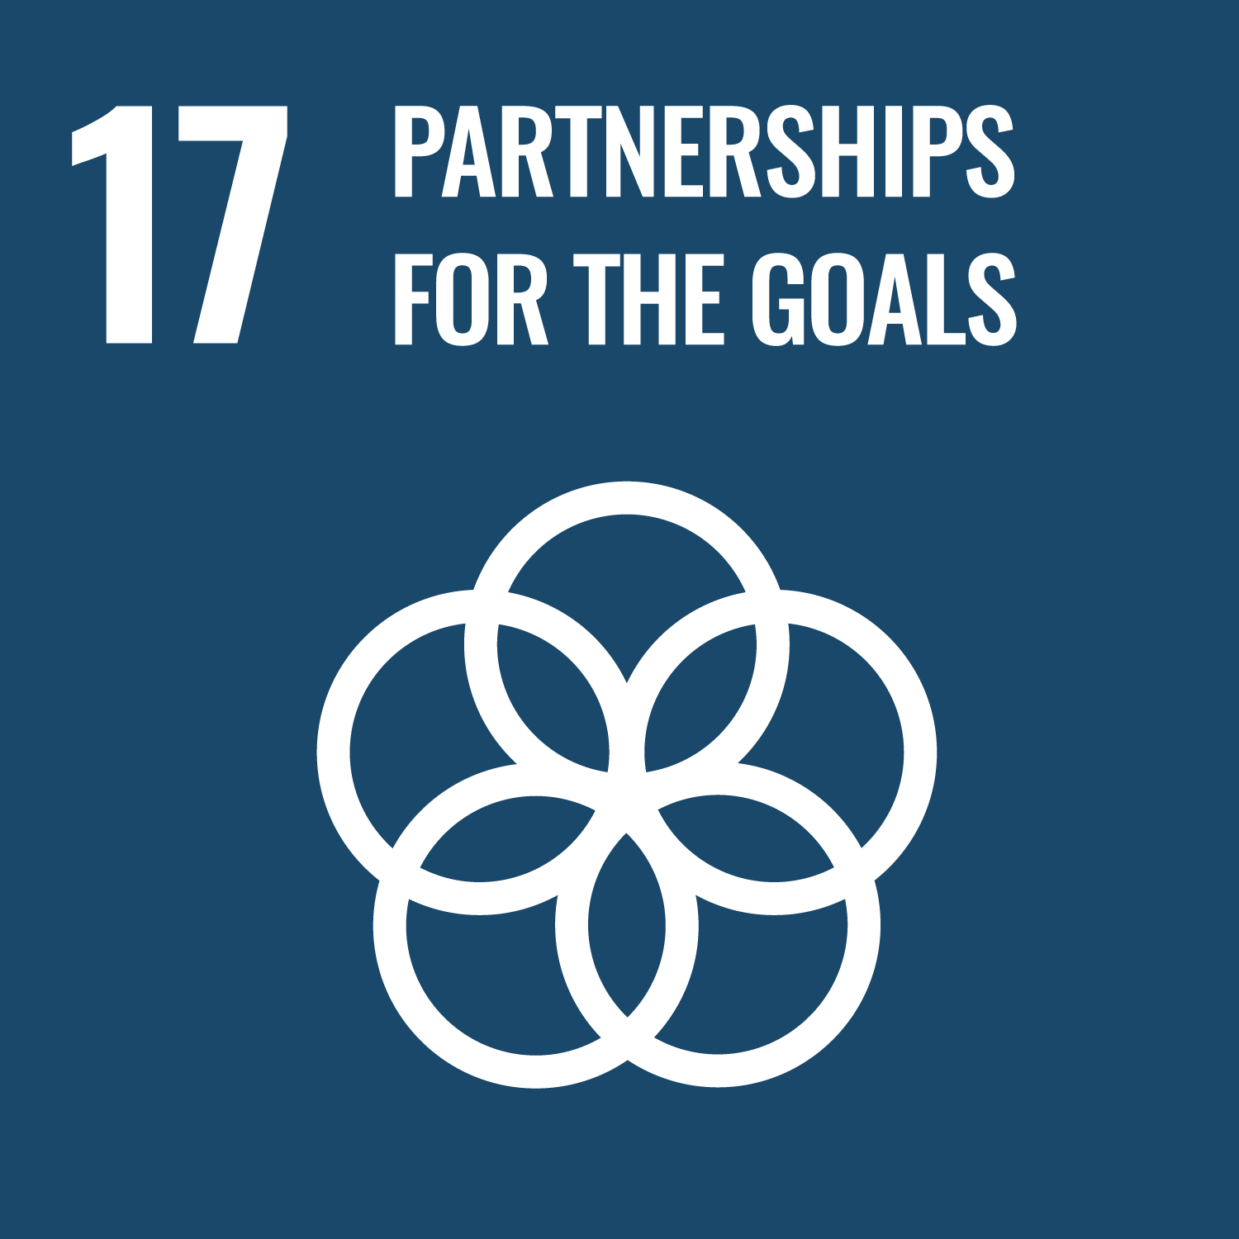 | The feasibility study is highly relevant in the context of the ongoing global energy transition and climate change mitigation efforts as the insights derived would ultimately help to improve upon long- and short-term decision-making. On the national scale, the results of the study could contribute to energy security, water management and natural resource preservation.  Additionally, this project effectively meets at least three of the UN’s Sustainable Development Goals, including (but not limited to):  - SDG 7 (Affordable and clean energy) by enabling a better understanding of future water availability and potentially reducing errors by 30%.  - SDG 13 (Climate Action) by potentially optimizing energy production by 10% throughout the Autumn, Winter and Spring season with the same assets.  - SDG 17 (strengthening the Global Partnership for Sustainable Development) by working together with leading industry stakeholders that are committed to the international efforts to reach decarbonization targets by 2040.

Wegaw’s team offers a cost-effective solution that empowers hydropower companies with invaluable insights, through which to further reduce runoff errors and, consequently, further reduce the errors in water inflow predictions, that would lead to greater sustainability opportunities and additional revenue generation per power plant annually.

Zillertal Alps, South Tyrol, Italy taken by Eberhard Grossgasteiger (Source: Unsplash)

“The energy industry is proactively exploring ways to balance energy price and generation volatility that is driven primarily by the uncertainty in renewable energy production. Thanks to our detailed, remote and near real-time observation abilities, we can help to optimize power production and electricity trading. This project in particular is enabling us to make greater steps into the European Alps whilst improving our validity within the region.” | Daria Lüdtke  CTO

Today, our team is strategically positioned in the energy industry to enable a faster transition from fossil fuels through near real-time snow monitoring expertise. Currently, Wegaw works with more than 15 hydropower companies around the world who trust the datasets and utilize them to enhance their legacy systems and spearhead new innovative and sustainability focused renewable energy projects.

To learn more about Wegaw, you can watch our video, follow us on LinkedIn and visit wegaw.com. For any questions about how to work with us, please send an email to info@wegaw.com.

— ENDS —

Introduction to Wegaw
Headquartered in Morges, Switzerland, Wegaw combines satellite imagery, AI and machine learning algorithms to create the underlying climate tech solution that supports the energy sectors’ transition to sustainable and clean energy. Wegaw’s multinational team has backgrounds from CERN, United Nations, HP, and is supported by the European Space Agency and the Swiss Energy Agency. Since the company was established in 2016, Wegaw has begun operating in six countries, delivering impactful datasets to more than 15 clients and 30+ power plants without the need for further investment in infrastructure. Moreover, Wegaw is working with government bodies and national agencies to reduce CO2 emissions and aid international efforts to attain Net Zero status. Find out more at https://wegaw.com

Press Contact Partnership Enquiries
Mrs Becky Rowland, Marketing Manager  (English and German)  Email: becky.rowland@wegaw.com | Mr Ion Padilla, CEO & Co-Founder  (Spanish, English and French)  Email: ion.padilla@wegaw.com

About ESA Space Solutions
ESA Space Solutions is the go-to place for great business ideas involving space in all areas of society and economy. Our mission is to support entrepreneurs in Europe in the development of business using satellite applications and space technology to improve everyday life. For more information please visit us at https://business.esa.int

About Enel
Enel, which celebrates its 60th anniversary this year, is a multinational power company and a leading integrated player in the global power and renewables markets.
At global level, it is the largest renewable private player, the foremost network operator by number of end users and the biggest retail operator by customer base. The Group is the worldwide demand response leader and the largest European utility by ordinary EBITDA.
Enel is present in 30 countries worldwide, producing energy with over 90 GW of total capacity.
Enel distributes electricity through a network of over 2.2 million kilometers to more than 75 million end users. The Group brings energy to around 70 million homes and businesses. Enel’s renewables arm Enel Green Power has a total capacity of more than 54 GW and a generation mix that includes wind, solar, geothermal, and hydroelectric power, as well as energy storage facilities, installed in Europe, the Americas, Africa, Asia, and Oceania. Enel X Global Retail, Enel's global business line active in the areas of energy supply and efficiency, has a total capacity of 7.9 GW of demand response managed globally and has installed 62 MW of behind-the-meter storage capacity. In addition, Enel X Way is the Group’s new company fully dedicated to electric mobility, managing more than 380,000 public and private EV charging points worldwide, both directly and through interoperability agreements.
Enel’s leadership in the different categories is defined by comparison with competitors’ FY 2021 data. Publicly owned operators are not included.
For more information please go to our website at https://www.enel.com

