FOR IMMEDIATE RELEASE
14 June 2023, Lausanne, Switzerland

Climate-tech startup Wegaw awarded CHF 1.4M Swiss Accelerator Grant by Innosuisse

- Swiss startup Wegaw embarks on a two-year project to build one of the most sophisticated geospatial digital twin technologies supported by Innosuisse.

- Wegaw’s technology enables near real-time snow, glaciers, and water monitoring, helping to forecast future water and energy availability with unprecedented accuracy.

Global snow cover has significantly declined, resulting in an entire months’ worth of snow being lost at low and medium altitudes (below 2,000 metres, measured over a 50-year period). This has a significant impact on the nation’s ability to accurately forecast and generate energy, particularly during more uncertain periods, such as the height of summer and mid-winter.

With this new project, Switzerland’s government is helping energy companies and public agencies to prepare improved energy shortage plans based on water availability forecasts.

Natural lake of Caumasee, Flims, Switzerland at different water levels

Published Feb 10th 2023 Published May 28th 2021

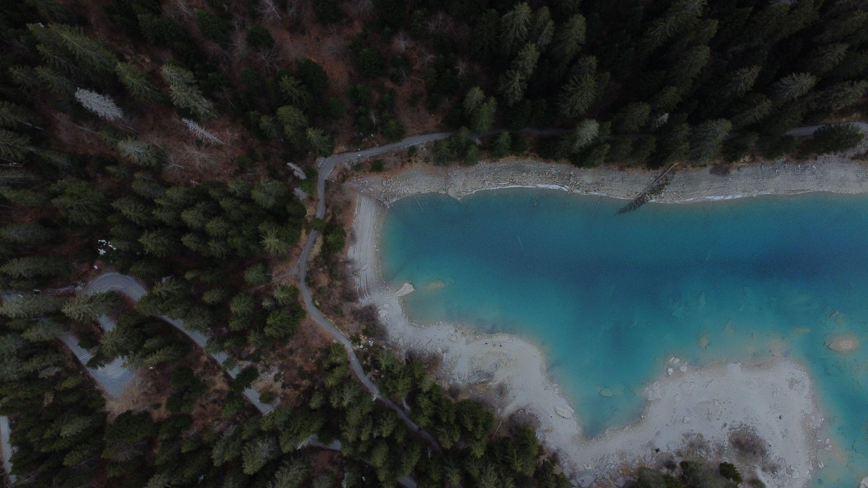Published on May 6th 2022. Lake levels across Switzerland are changing as the climate changes, as evidenced in this report.

Wegaw is set to partner with Hydrique and Mitta to deliver a water and energy forecasting tool using geospatial technology that will empower Switzerland to anticipate electricity outages and drought situations. By combining observation data from satellite and drone imagery, as well as Global Navigation Satellite System (GNSS) stations, in-situ measurements and weather stations, a highly accurate digital twin of water, glacier and snow resource datasets will be created that will equip the Swiss energy, water and utility industries with the ideal climate change forecasting tool that can flag potential shortage scenarios or climate anomalies.

“We are strongly supportive of Wegaw and the R&D pursuant of snow and water analysis.”

Monica Jill Vaksdal, Country Manager at Mitta Norway

“Alongside Mitta and Hydrique, Wegaw is set to deliver a long-term forecast that is effective and resilient to climate anomalies, so that volatile market situations and downside risks may be averted.”

Daria Lüdtke, Chief Operations Officer

Wegaw aims to build the most advanced snow, glacier, and water forecasting tool by partnering with inflow forecast and environmental observation companies Hydrique and Mitta to gain insights into future water availability for public, agricultural and hydropower usage, as well as potential flood risks. By adopting this cutting-edge technology, Swiss companies, utilities, and public agencies will have near real-time data with which to increase electricity generation and optimize energy trading pricing strategies. This partnership will also help those involved to prepare for potential shortage and climate anomaly scenarios as early as possible, and thus tackle diminishing water supplies, maximizing renewable energy production whilst creating more efficient Water Demand Management Strategies.

“We are very proud to have been chosen in this highly competitive process to support Switzerland's commitment to combating the national and global water crisis. Based on the impressive results from our recently completed Swiss collaboration with nine hydropower operators and Hydrique which saw long-term forecasting errors significantly reduced by up to 50%, our energy transition accelerating team is certainly well placed to complete this new phenomenal opportunity for which we are exceptionally grateful.”  Ion Padilla, CEO & Co-Founder | 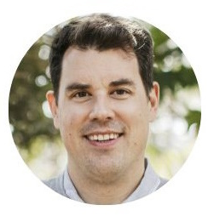

The new geospatial digital twin technology will be piloted and tested at home and abroad by leading hydropower companies in Scandinavia and Canada. Over a 12-month period, Wegaw will lead several pilots to improve a short-term forecast for energy and water output optimization as well as a long-term forecast for financial risk reduction and trading value maximization. The objective is to help hydropower and water management organizations to become more resilient to climate change, by enabling their forecasting capabilities to be as accurate as possible.
Further participant announcements and project updates will be released in due course. To get involved and to find out more, please get in touch with the Wegaw team directly at wegaw.com/contact-us.

— ENDS —

Project Lead | Project Partners | International Project
Wegaw SA | Hydrique Ingénieurs HJ Sàrl  Mitta Group | 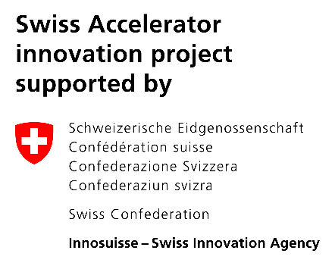  Innosuisse

About the Innosuisse Swiss Accelerator
The Innosuisse Swiss Accelerator is a transitional measure for Horizon Europe that provides grants to innovative Swiss SMEs and start-ups to receive direct financial support for ground-breaking projects that demonstrate significant potential. The program aims to facilitate the growth of Swiss companies and supports latest developments within engineering, life sciences, energy, social sciences and business management, IT & Communications, and environment. Innosuisse received 752 project proposals and after a rigorous three-stage assessment process, 53 projects (7% of the applications) were approved to receive up to CHF 2.5M each. The final total funding grant by this grant amounted to CHF 112M. You can find out more by click here.

About Wegaw
From its headquarters in Switzerland and offices in Spain, Wegaw is a climate-tech that delivers proven and highly accurate snow and water Digital Twins to enhance trading and production capabilities and accelerate a sustainable energy transition. Through the power of geospatial fusion with satellite imagery and machine learning, companies around the world are benefiting from the multinational teams’ digital transformation experience with CERN, United Nations and HP. Wegaw is supported by the European Space Agency, the Swiss Energy Agency, as well as numerous high profile investors, and is operating in six countries, delivering impactful datasets to energy companies, government bodies and national agencies for more than 40 power plants - all without the need for further investment in infrastructure. Wegaw’s pioneering team is proud to help reduce CO2 emissions, achieve UN SDGs and aid efforts to strengthen global sustainability.

Wegaw Corporate Contact
Ion Padilla, CEO & Co-Founder
Email : ion.padilla@wegaw.com
LinkedIn

Wegaw Media Enquiries
Becky Rowland, Marketing Manager
Email : becky.rowland@wegaw.com
LinkedIn

About the Mitta AS and Mitta Group
Mitta AS is the Norwegian subsidiary of Mitta Group, and large geo-monitoring corporation with headquarters in Finland, with an annual turnover of EUR60M and almost 600 employees in Finland, Sweden and Norway. Mitta’s customers span from the energy sector to infrastructure and building, aquaculture, district heating, mining industry and nuclear, and much more. Mitta makes sustainable decision-making easy with our reliable geodata and services and have a special focus on innovation and digitalization.

Mitta Corporate Contact
Monica Jill Vaksdal, Country Manager
Email : monica.vaksdal@mitta.no
LinkedIn

About Hydrique Ingénieurs
Hydrique Ingénieurs is a Swiss SME, specialized in digital twins for hydropower and water networks. Its products focus on real-time river flow forecasting, flood and drought management. More than 60 customers benefit from this strategic information, in the hydropower, flood management, agriculture and wastewater sectors. For more information, please visit www.hydrique.ch

